EWOFS’16 Submission Instructions

Submission link: http://spie.org/submissions/submit/overview.aspx?EventId=2235395

Upon clicking the above link, you will sign in to your account.
*If you do not have a SPIE.org account, then you will need to create one.
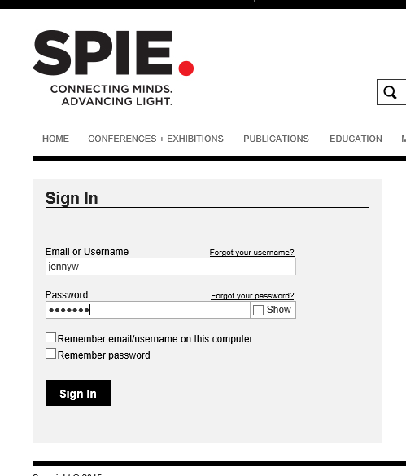

Step 1. Enter your paper’s title.

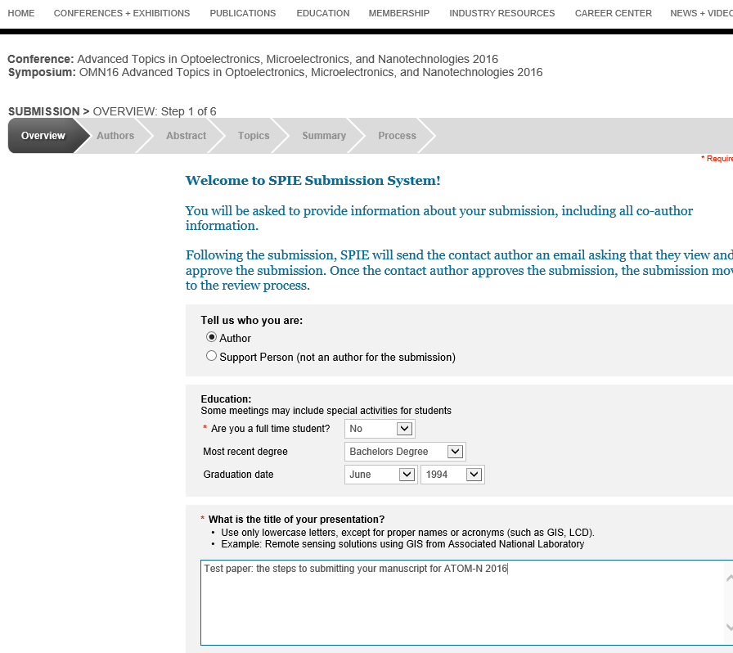
Step 2. Enter the contact author and coauthors. The contact author is the only author with access to the submission.

Enter the speaker’s biography.

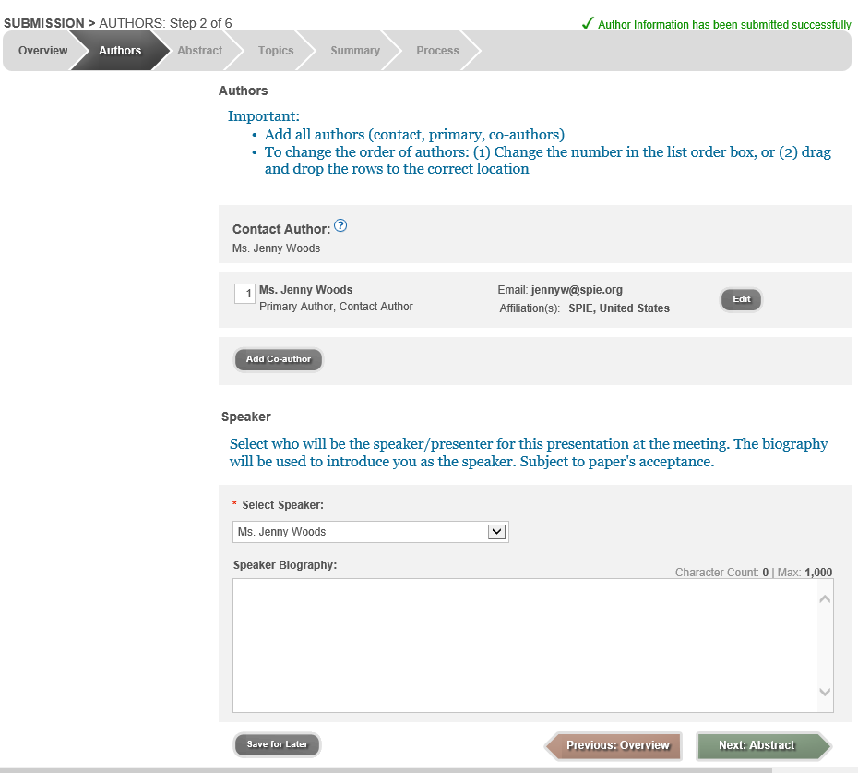
Step 3. Enter a 35-word abstract in the first text block. If your paper is accepted, this abstract text will be published on the EWOFS’2016 webs site, and in the final program.

In the second text block, cut/paste the abstract from your manuscript.
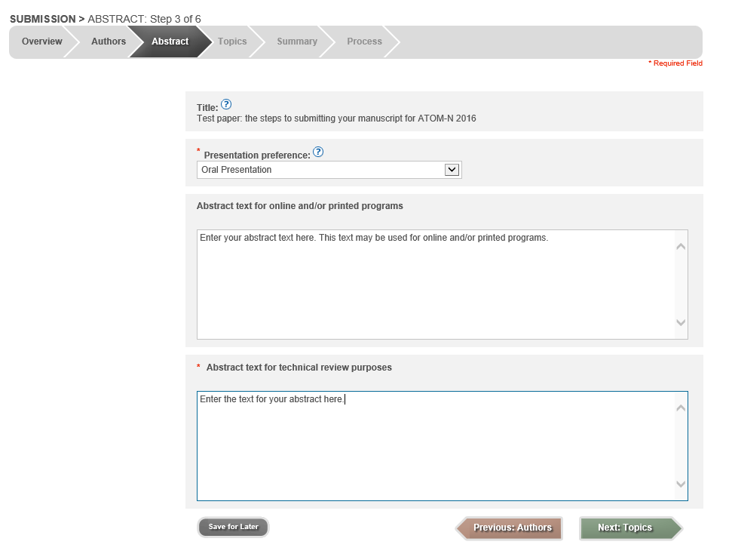
Step 4. Select the Topic that best fits your submission.
Enter key words (optional).
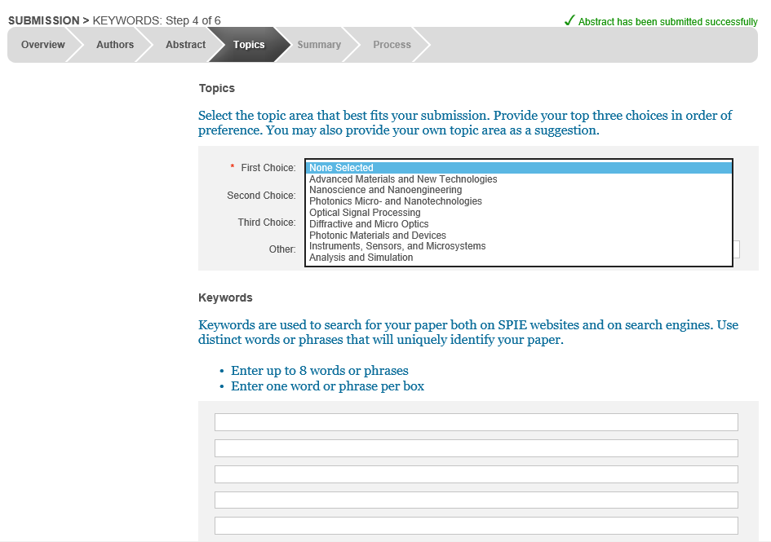
Step 5. Summary
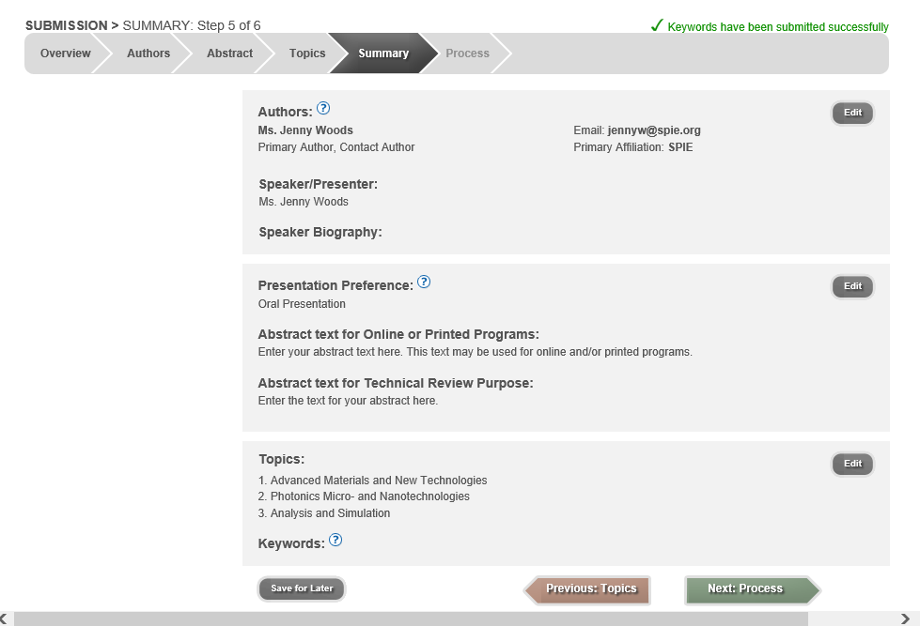
Step 6. Submission
Your paper will automatically receive a tracking number.
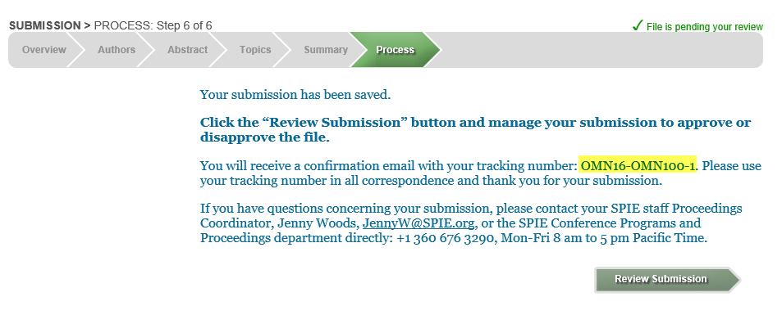

If you need to make a change to your submission, go to http://spie.org/myaccount. Go to ‘Manage Active Submissions.’ Under your presentation, you will see a hyperlink, ‘Submit Revision.’
